Institute of Computer Technology
B. Tech Computer Science and Engineering

Sub: Algorithm Analysis and Design
Practical 1

(1) There are 2 chefs, namely chef 1 and chef 2 in the MasterChef competition. The judge is going to judge on the basis of 3 categories: presentation, taste and hygiene to prepare the dishes. The marking is scaling from 1 to 100. The rating for chef 1 challenge is the triplet a = (a[0], a[1], a[2]), and the rating for Chef 2 challenge is the triplet b = (b[0], b[1], b[2]), where 0 index is presentation, 1 index is taste and 2 index is hygiene.
The task is to find their comparison points by comparing a[0] with b[0], a[1] with b[1], and a[2] with b[2].
- If a[i] > b[i], then Chef 1 is awarded 1 point.
- If a[i] < b[i], then Chef 2 is awarded 1 point.
- If a[i] = b[i], then neither person receives a point.
Comparison points are the total points a person earned.
Given a and b, determine their respective comparison points.
Design the algorithm for the same and implement using the programming language of your choice. Make comparative analysis for various use cases & input size.
Sample Input 1
27 48 70
89 26 7
Sample Output 1
2 1
Explanation 1
Comparing the 0th elements, 27<89 so Chef 2 receives a point.
Comparing the 1st and 2nd elements, 48>26 and 70>7 so Chef 1 receives two points.
The return array is [2,1].

Code:
chef1 = []
chef2 = []
chef1score = 0
chef2score = 0
print ("_________________________________________\n")
print ("Enter the rating for two chef: ")
print ("Press 1 for Presentation ")
print ("Press 2 for taste ")
print ("Press 3 for hygiene")
print ("_________________________________________\n\n")

for i in range (3):
chef1.append(int(input(f"Enter Chef 1's rating for {i+1}:")))
print ("\n_________________________________________\n\n")

for i in range (3):
chef2.append(int(input(f"Enter Chef 2's rating for {i+1}:")))
print ("\n_________________________________________\n\n")

for i in range (3):
if chef1[i] > chef2[i]:
chef1score += 1

elif chef2[i] > chef1[i]:
chef2score += 1

print (f"Chef-1's Score is {chef1score}\n")
print (f"Chef-2's Score is {chef2score}\n")

output:
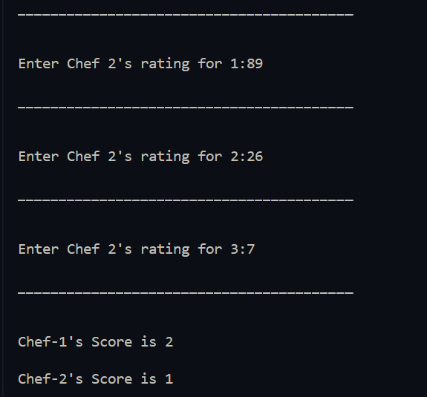
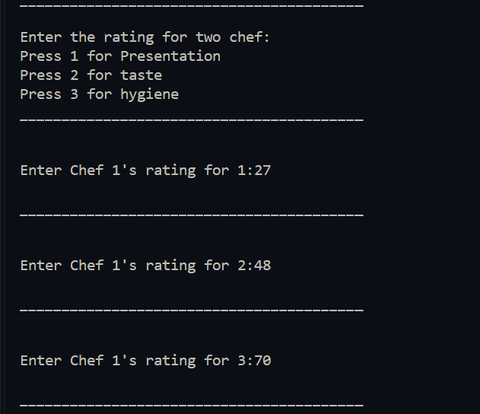

(2) Let us suppose that you are having an array containing both positive and negative numbers. Given the numbers you are supposed to find 2 such elements such that the sum of those numbers is closest to zero.

Code:

array = list (map ( int,input().split() ))
min = abs (array[0]+array[1])
for i in range (0,len(array)):
for j in range (i+1,len(array)):
temp = array[i]+ array[j]
if abs(temp) < min :
min = abs(temp)

for i in range (0,len(array)):
for j in range (i+1,len(array)):
temp = array[i]+ array[j]
if abs(temp) == min :
print(array[i],array[j])

Sample Input 1
15, 5, -20, 30, -45

Sample Output 1
15, -20

Explanation 1
In all the comparison, the sum of 15 and -20 is smallest amount among all other comparison.

Output:
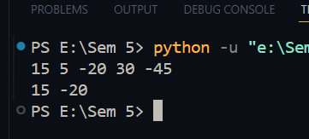

Sample Input 2
15, 5, -20, 30, 25

Sample Output 2
15, -20 & -20, 25

Explanation 2
In all the comparison, the sum of 15,-20 & -20, 25 is smallest amount among all other comparison.

